# HOW TO MEASURE YOUR KITCHEN OR BATH FOR NEW CABINETS

Accurate measurements of your kitchen or bath are important in designing your new cabinets. .

## FLOOR PLAN

You will need to carefully configure the exact dimensions of your room. Your completed floor plan should resemble the diagram below. Be sure to show the exact locations of doors, windows, hood vents, exhaust, gas lines, water line, drain line, outlets, switches, light fixtures, and heat vents.

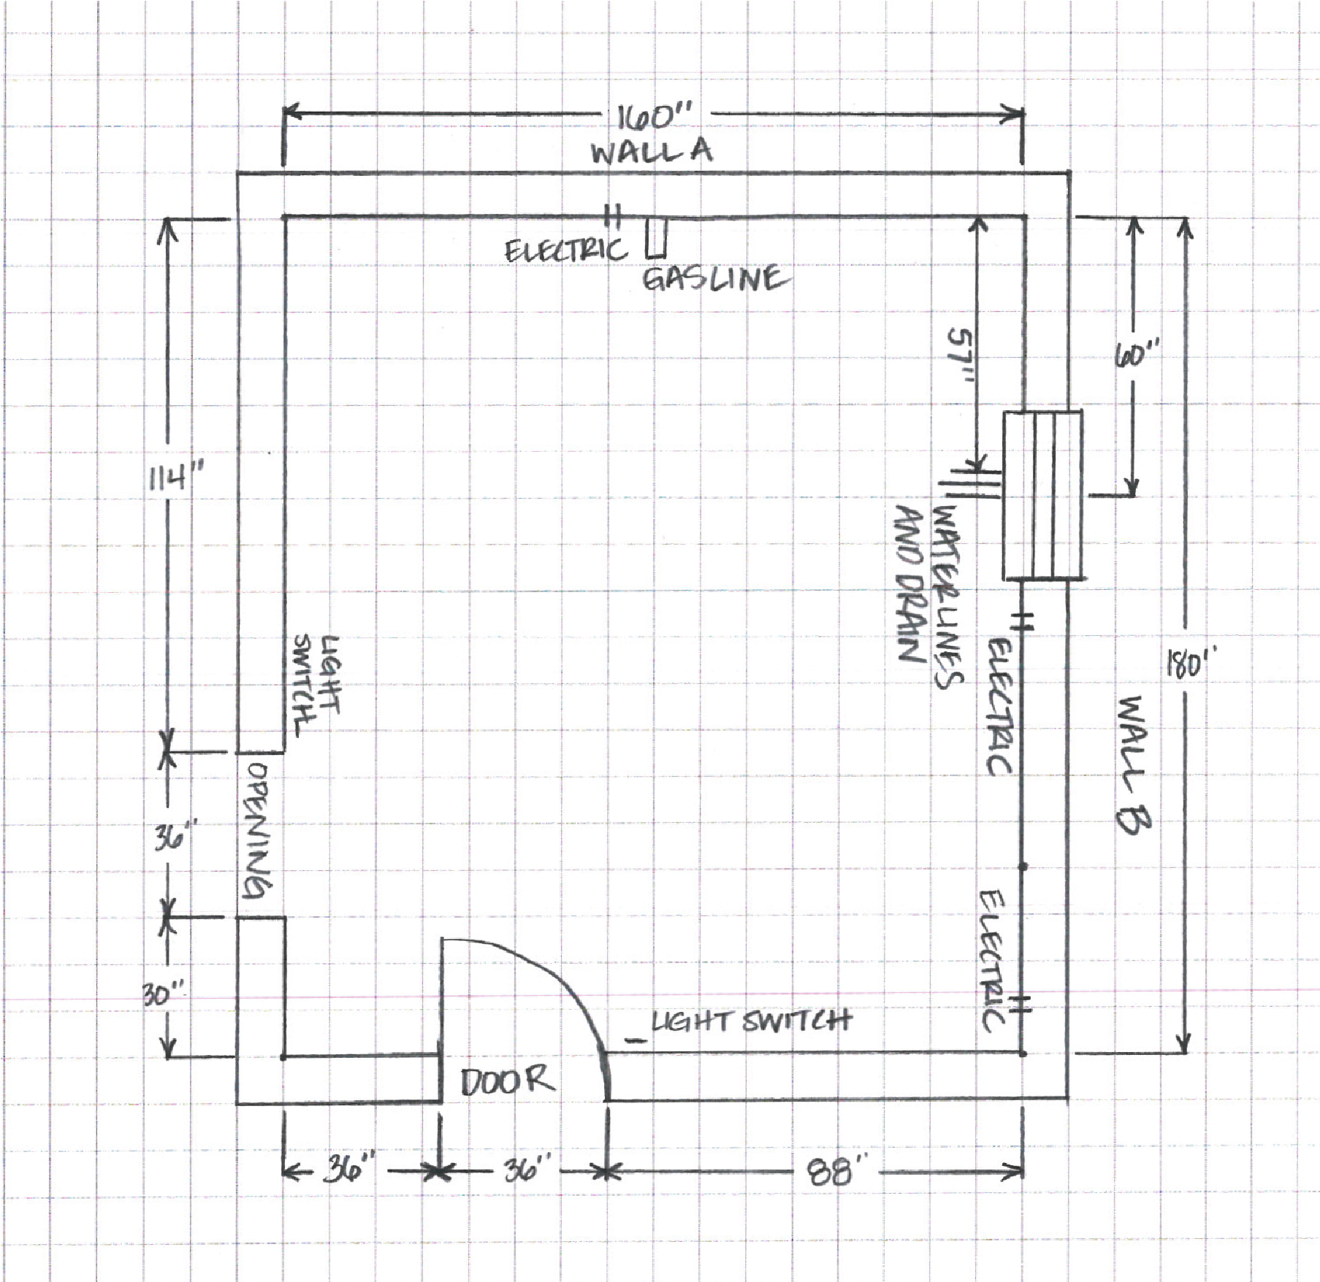

# 

# HOW TO MEASURE YOUR KITCHEN OR BATH FOR NEW CABINETS

Using a tape measure and graph paper, measure your room using the following steps.

## HORIZONTAL MEASUREMENT

1. Measure from wall to wall at 36” height
2. Measure from corner to window or door opening.
3. Measure across opening from trim edge to trim edge.
4. Measure from edge of trim to far wall. Compare sum of #2, #3 and #4 measures to step #1.
5. Mark exact location of water, drain, gas lines, electrical outlets and switches on drawing.
6. Measure from wall to wall above window and compare to #1.

## VERTICAL MEASUREMENT

1. Measure from floor to window sill
2. Measure from window sill to top of window.
3. Measure from top of window to ceiling.
4. Measure from floor to ceiling - Compare to sum of #7, #8, and #9.

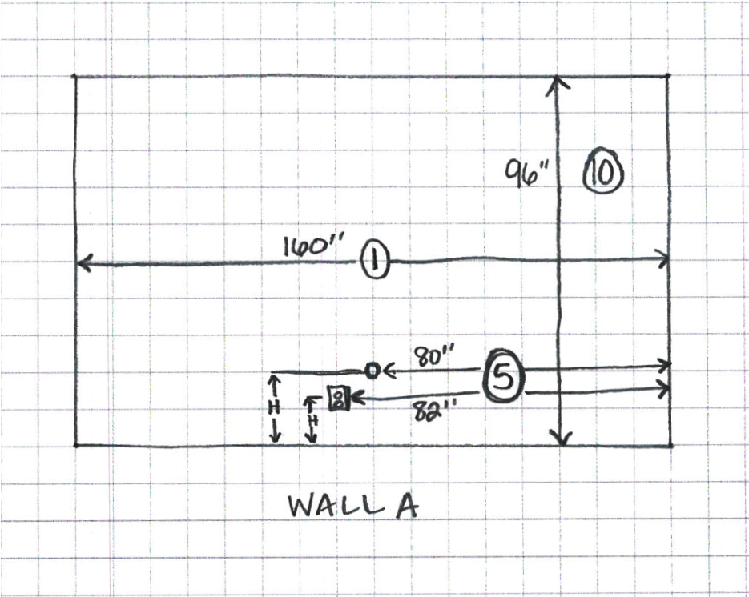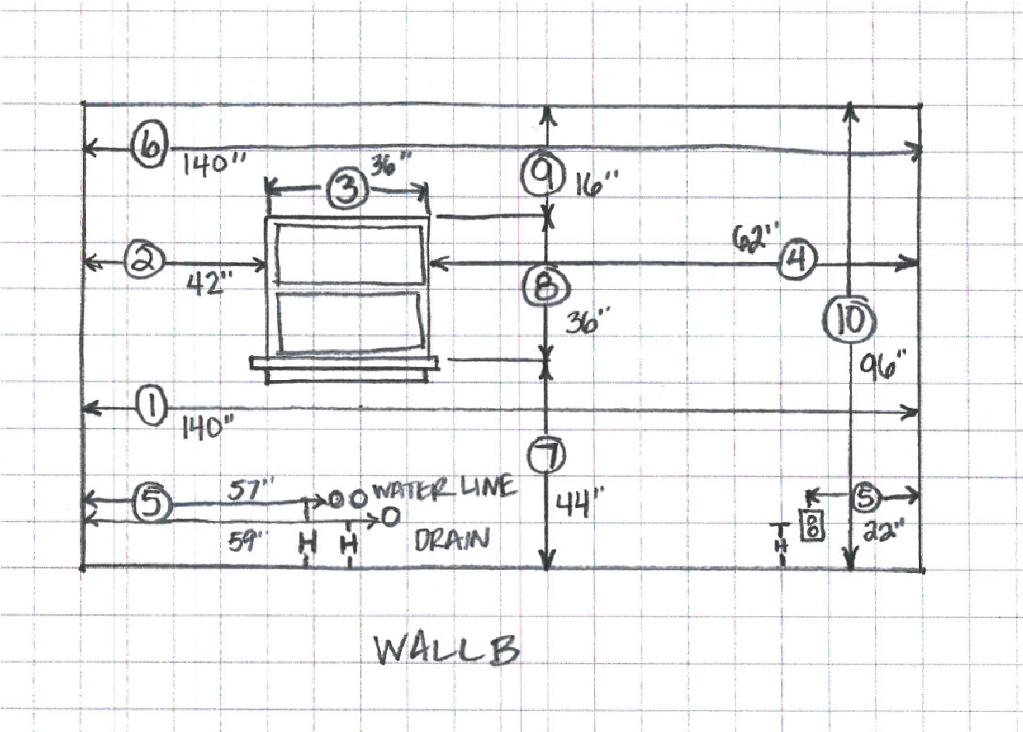

Name __________________________________________________________________ Address ________________________________________________________________ City ________________________________ State ________ Zip ______________



Phone ______________________ Email ___________________________________

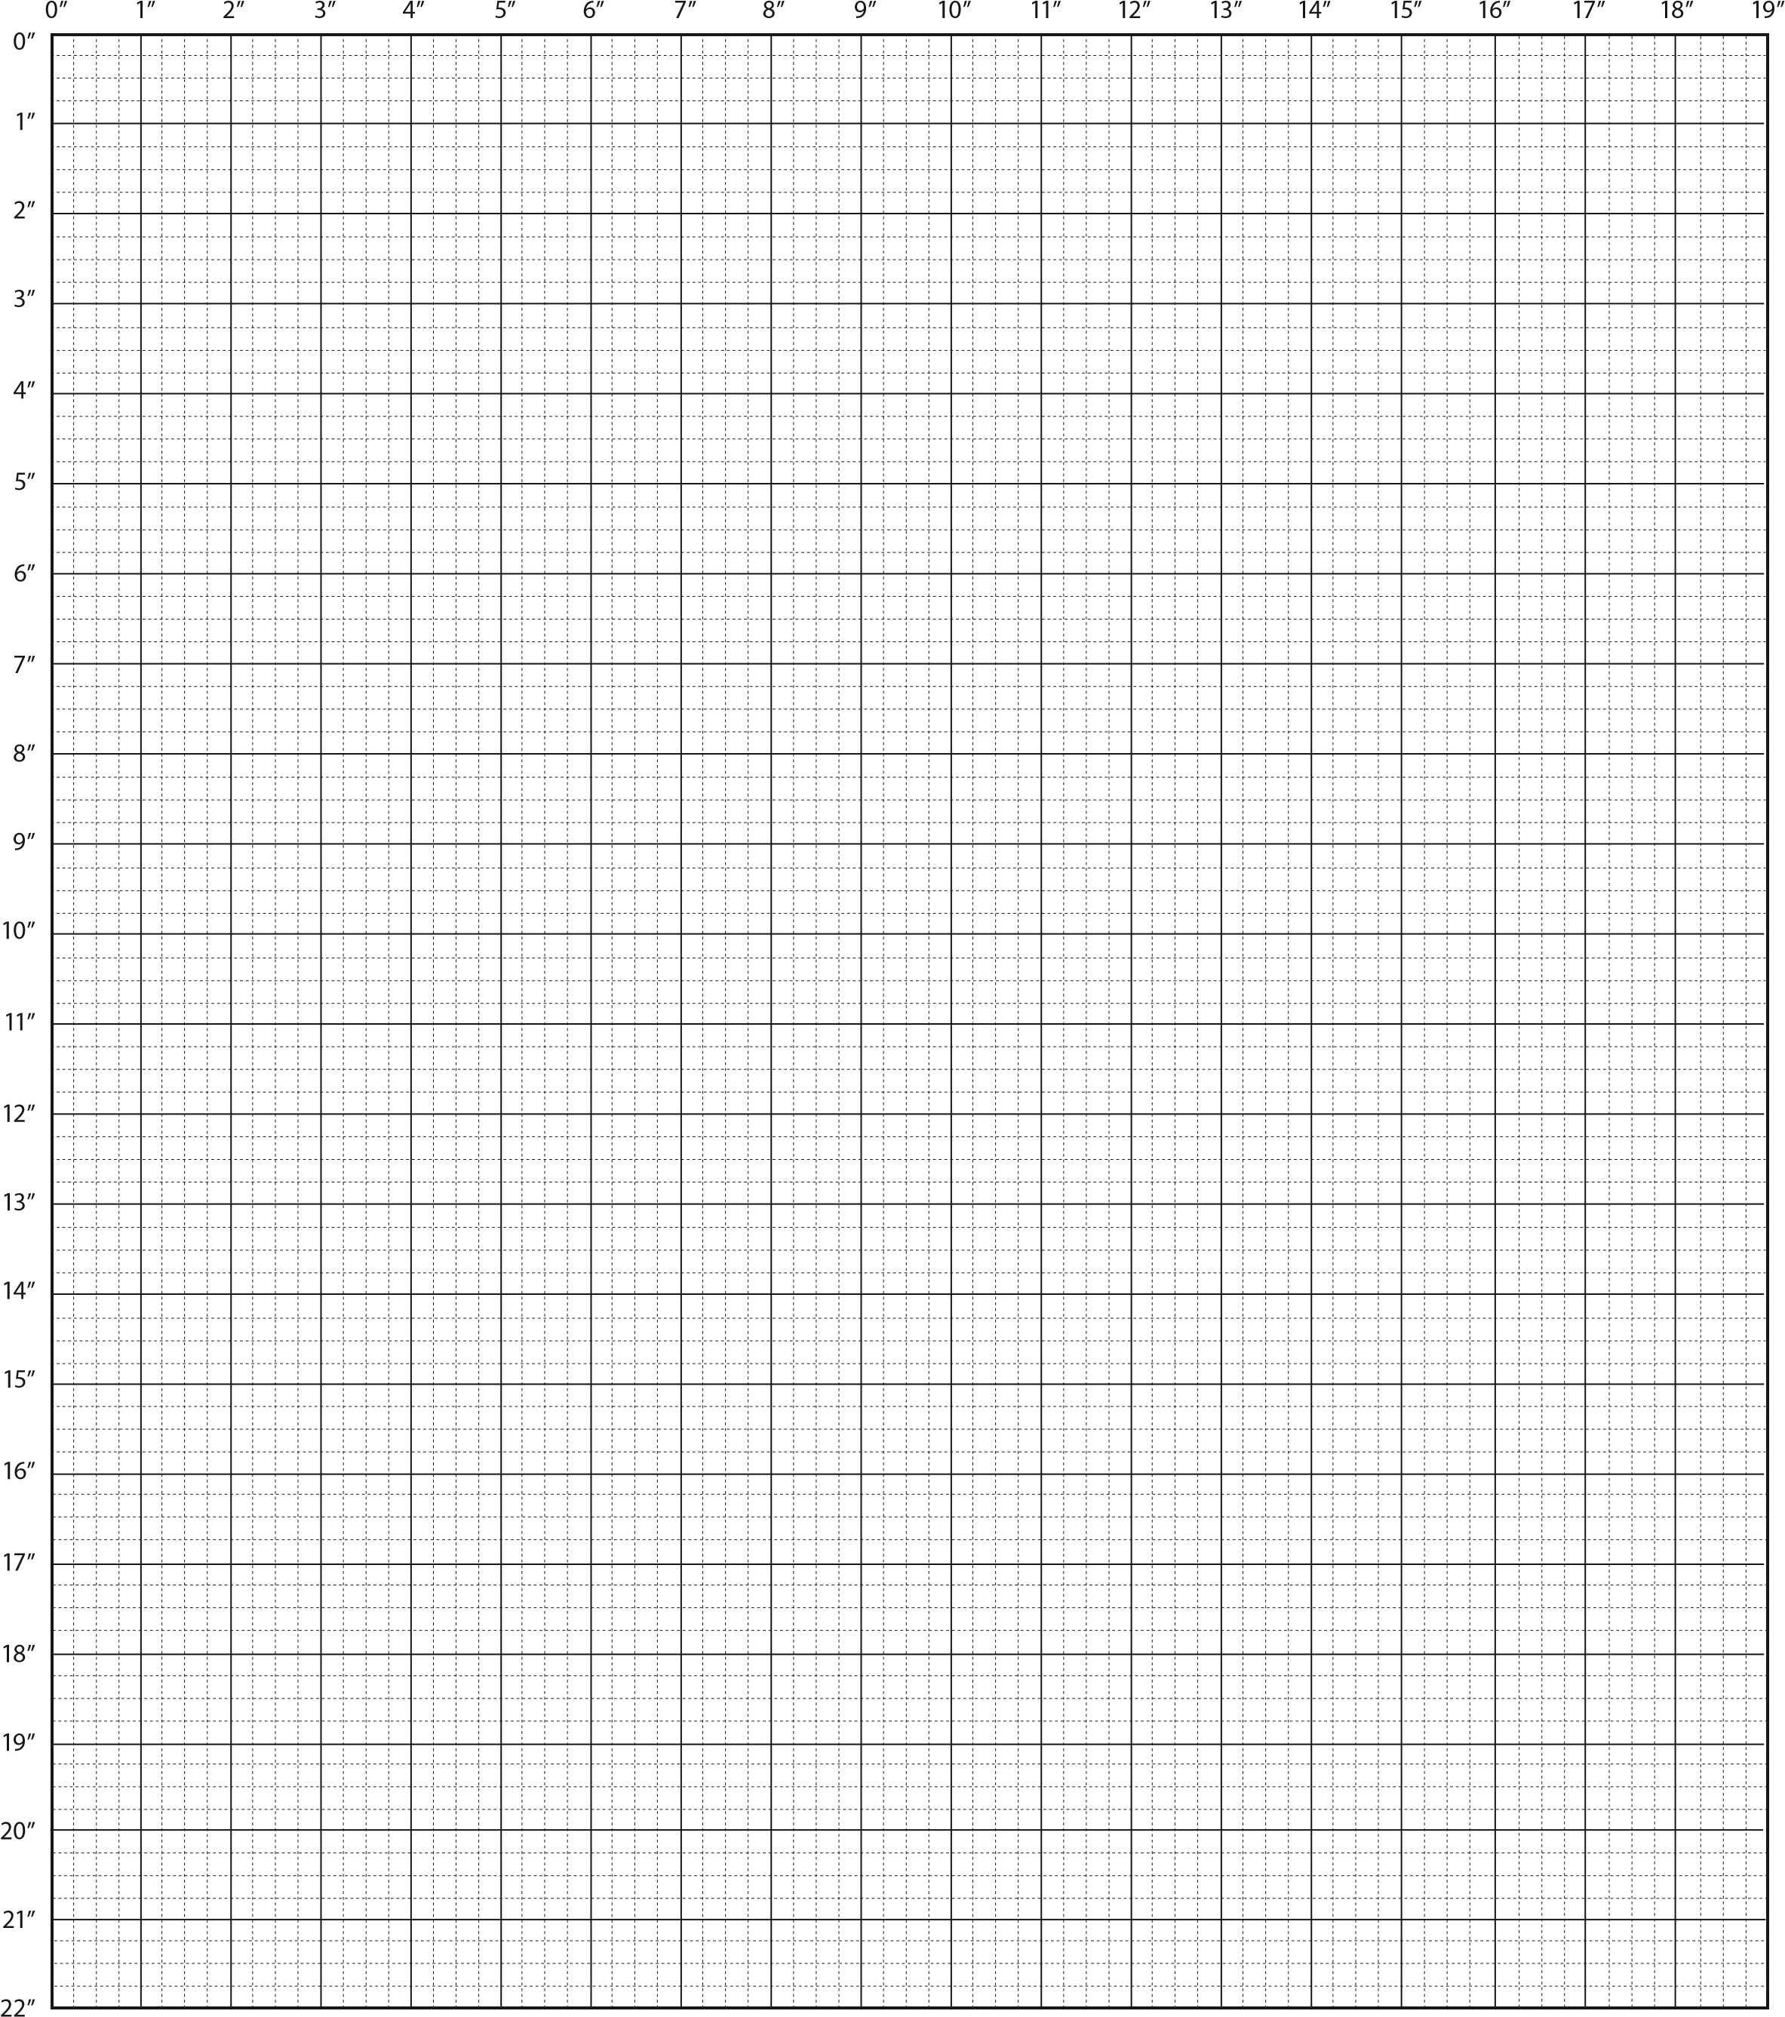

Each large square represents 1 square foot and the small squares represent 3”

# 

# APPLIANCE AND FIXTURE INFORMATION

List desired or existing appliances for drawing. Be sure to indicate 220 volt outlets, wall mounted appliances and fixtures, telephone and cable locations. Also note gas line and appliance locations.

|  |  |  |  |
| --- | --- | --- | --- |
| **Appliance** | **Type** | **Size (W x D x H)** | **Hinge Position L/R**  (Facing Appliance) |
| Refrigerator |  |  |  |
| Range |  |  |  |
| Cooktop |  |  |  |
| Exhaust Hood |  |  |  |
| Wall Oven |  |  |  |
| Microwave |  |  |  |
| Dishwasher |  |  |  |
| Sink |  |  |  |
| Disposal |  |  |  |
| Compactor |  |  |  |
| Freezer |  |  |  |
| Other |  |  |  |
| Other |  |  |  |

**SPECIAL INSTRUCTIONS OR NOTES**

______________________________________________________________________________________

______________________________________________________________________________________

______________________________________________________________________________________